

D Y PATIL COLLEGE OF ENGINEERING AND TECHNOLOGY

KASABA BAWADA, KOLHAPUR

A

PROJECT- II

‘LOCAL PROPERTY LISTING’

Submitted by

**Roll No Name**

15 Mr. Hrushikesh Charudatta Shinde

23 Mr. Romit Rakesh Shirke

07 Mr. Deon Chris Kiran Fernandes

Under the guidance of

Mrs. Tejashri V. Deokar

Class: TY (CSE Data Science) Div : A Batch: T1

DEPARTMENT OF COMPUTER SCIENCE AND ENGINEERING

Year: 2022-23

D. Y. PATIL COLLEGE OF ENGINEERING AND TECHNOLOGY

KOLHAPUR

CERTIFICATE

This is to certify that the project group consisting of following members have satisfactorily completed the Project-II work entitled “Local Property Listing” at TY (CSE DS) semester – VI as prescribed in the syllabus of this institute.

Roll No Name Exam No

07 Mr. Deon Chris Kiran Fernandes

15 Mr. Hrushikesh Charudatta Shinde

24 Mr. Romit Rakesh Shirke

Date:

Place:

Mrs. Tejashri V. Deokar Mrs. Tejashri V. Deokar Dr. Mrs. Jyoti N Jadhav

Project Guide Project Coordinator HOD (DS)

Examiner Principal

DEPARTMENT OF COMPUTER SCIENCE AND ENGINEERING

ACKNOWLEDGEMENT

I would like to express my sincere gratitude to the following individuals and organizations who have contributed to the successful completion of this project:

First and foremost, I would like to thank my project guide, Mrs. Tejashri Deokar, for their invaluable guidance, continuous support, and expertise throughout the project. Their insightful feedback and suggestions greatly influenced the direction and quality of this work.

I would like to extend my appreciation to the dedicated team members, for their collaboration, hard work, and commitment. Their contributions and shared efforts significantly enhanced the outcomes of this project.

I am sincerely grateful to all those mentioned above, as well as anyone else who may have indirectly contributed to this project's success. Without their assistance, this work would not have been possible.

Date:

Place:

Name of Student Sign

1. Mr. Romit Rakesh Shirke

2. Mr. Hrushikesh Charudatta Shinde

3. Mr. Deon Chris Kiran Fernandes

|  |  |
| --- | --- |
| **Index** | |
| 1 | Introduction |
| 2 | Problem Statement |
| 3 | Objectives |
| 4 | Proposed Work |
| 5 | Implementation Details |
| 6 | Conclusion and Future Work |
| 7 | References |

**1. Introduction**

The real estate process can be time-consuming, frustrating and full of back-and-forth discussions between a seller. But, if you’re able to optimize the sales process, buying process, not only will you save time, you can close deals quicker. Also, handling the real estate sales process properly can ensure a seller, buyer will turn to you next time they want to sell or buy another property.

The site offers free user-generated classified advertisements for urban population around the world. The ecommerce firm allows people to rent, buy and sell by posting advertisements. We will be responsible for creating the customer to customer (C2C) selling market segment in India that did not exist earlier beginning at a local level.

In today's digital age, the internet has become a powerful tool for property transactions. Our website harnesses this potential by providing a user-friendly interface that enables you to create detailed property listings with ease. You can include comprehensive descriptions, high-quality images, and essential details such as location, amenities, and pricing.

With this project, we strive to provide an inclusive and transparent platform that promotes fair and successful property transactions. We value the users trust and are committed to maintaining the utmost confidentiality and security of your information.

Our project provides a simple solution to the complications involved in selling, buying, trading, discussing, organizing, and meeting people near you, wherever you may reside.

**2. Problem Statement**

In a city like Kolhapur, due to its readily available opportunities in the field of employment and education, people tend to migrate from other cities and reside in the main location, and it is not easy to find an abode which meets one requirement. Though there are many places available it is not advertised enough or made known to the outsiders. Thus, to solve this problem, we have come up with the project idea.

In this project, we have created a website through which, users can list their properties to be sold or rented. There will also be a home page, where potential buyers will be able to browse through different listed properties, and find the best place suited for them.

**3. Objective**

The objective of the project is to make a ‘Web - based Platform’ accessible to any user, to find a place to live, based on their budget, time of stay, accessibility.

A complete and efficient web application which can provide the online searching experience is the basic objective of the project.

Given below will be the main highlight of this application will be:

* To Provide a platform to be able to buy, sell, rent properties efficiently.
* Provide an online market presence, to attract more users.
* Provide filters, based on location, budget, duration of stay, etc.
* Provide an Image and Video Gallery to allow experience the property better.

By aligning with these objectives, we aim to establish our local property listing website as a trusted and valuable resource for property-related activities, benefiting both individuals seeking properties and those looking to sell or rent their properties.

**4. Proposed Work**

1. Project Planning and Requirements Gathering:

* Define the project scope, objectives, and deliverables.
* Conduct market research and analysis to identify target audience and competitors.

2. Website Design and Development:

* Design an intuitive and user-friendly interface for the website.
* Develop a responsive website that works seamlessly across different devices and screen sizes.
* Implement robust search functionality with advanced filters to enable users to find properties based on their specific criteria.

3. Database Management:

* Set up a database system to store and manage property listings, user profiles, and related data.
* Develop a reliable data architecture to ensure efficient storage and retrieval of property information.
* Implement data validation and security measures to protect sensitive information.

4. Deployment and Maintenance:

* Deploy the website on a reliable web hosting platform.

By accomplishing these proposed tasks, our project aims to create a robust and user-friendly platform that connects property owners, sellers, and potential buyers or renters, simplifying the property search process and facilitating successful property transactions in the local area.

**4.1 System Requirements**

Hardware Requirements:

* Operating System: Windows/ MacOS
* Internet Access

Software Requirements:

* Any Internet Browser
* VS Code Editor

**4.2 System architecture diagram**

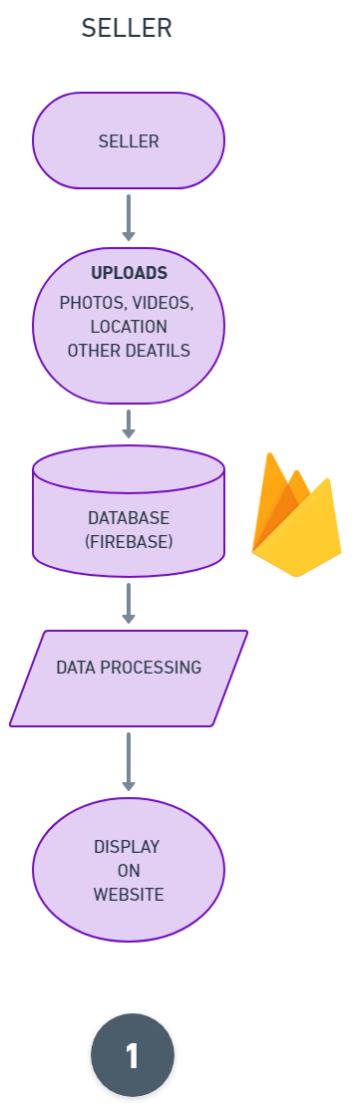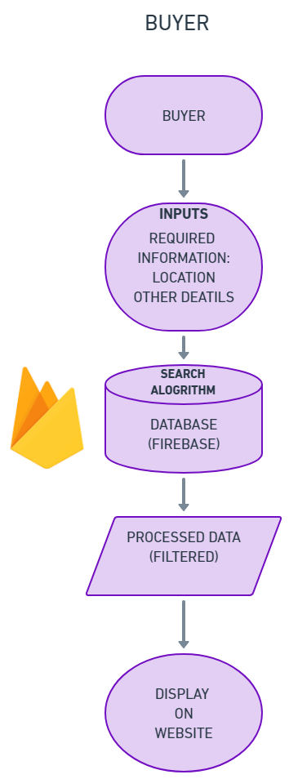

**4.3 Module details**

1. Login
2. Sign-up
3. Buyer
4. Seller

**5. Implementation Details**

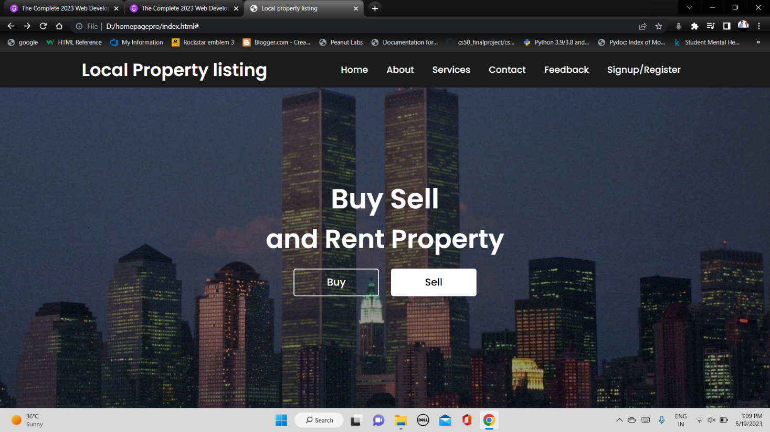This is the main Homepage. The users will be greeted with this screen. This page gives information about what the website does. It’s services, contact details, feedback link etc. the user can sign up, register or sign in to the service through this page.

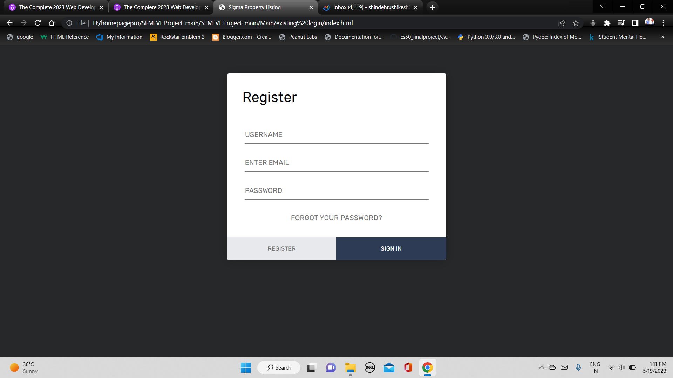

This is the registration page. The user will be able to register themselves here. The Data collected is the name, email and password. This is used for authentication purposes.

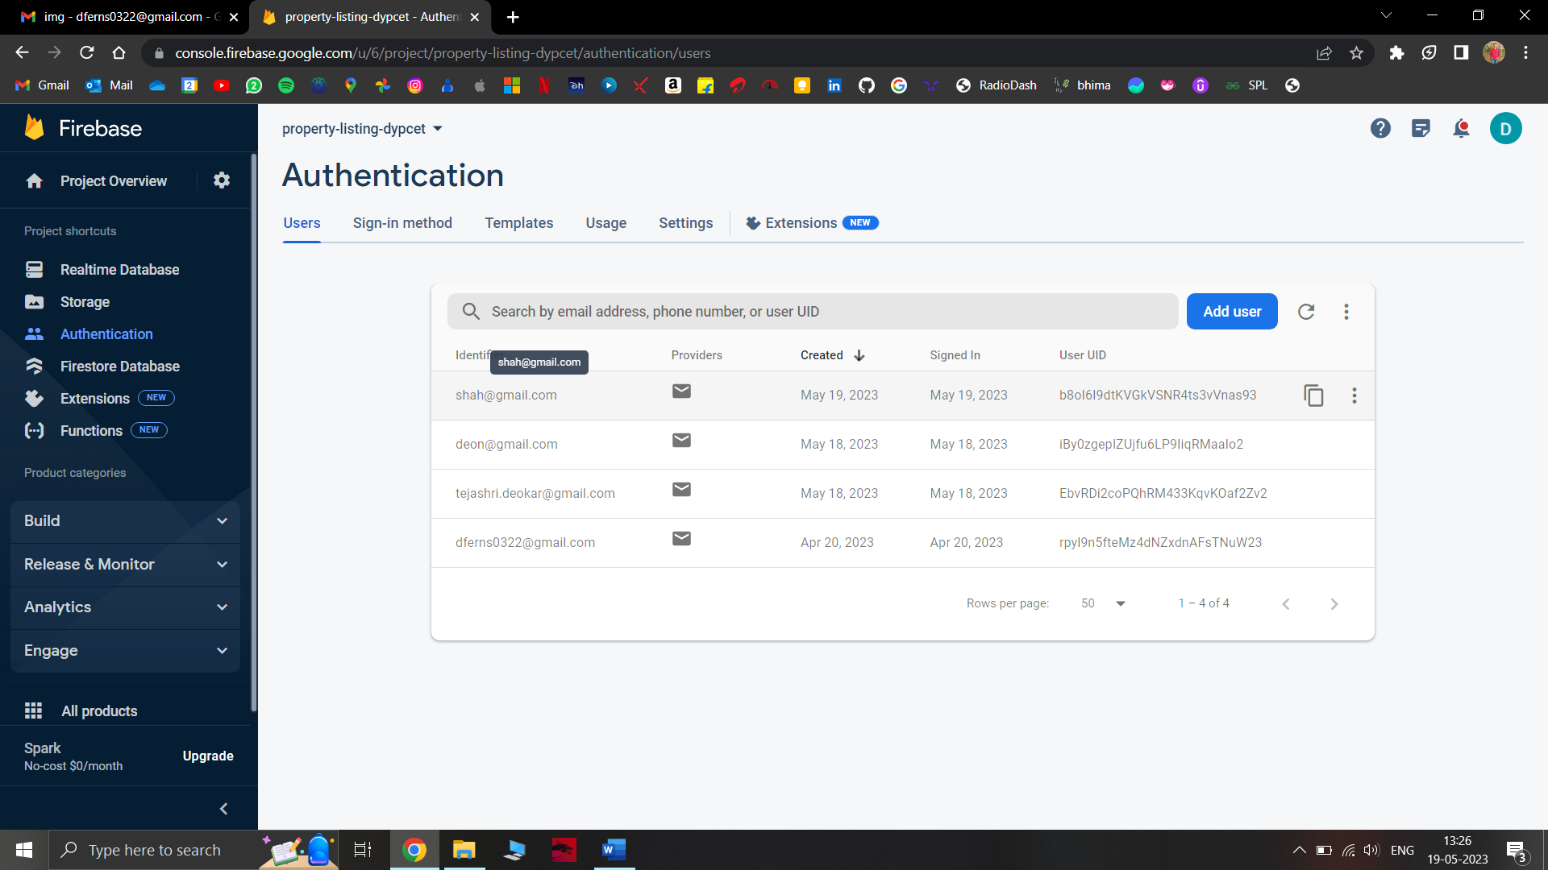

This is the the database Authentication page. An admin can view the information of the user’s here. We get all sorts of information related to the users here.

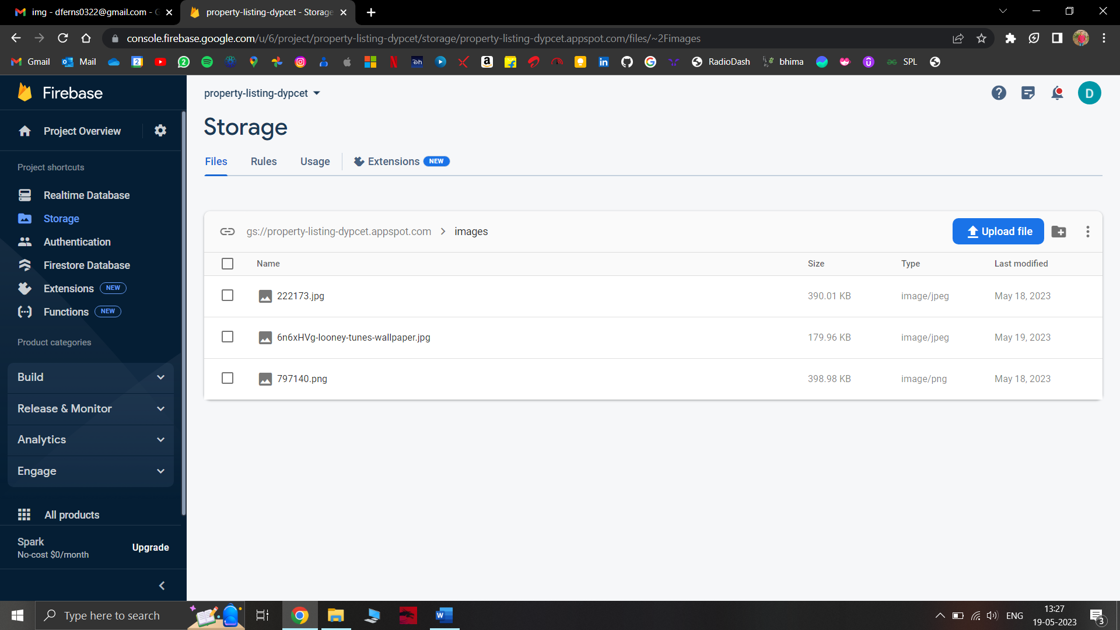

The Storage Sample. This Image shows the image uploaded by the users. The data as well as the metadata of the image can be viewed here. This makes it easier for the admin to monitor the images.

1. Technology Stack Selection:

* Made use of HTML, CSS, and JavaScript for frontend development to create an interactive and visually appealing user interface.
* Selected Googles Firebase as the database management system to store property listings and user data.

2. User Registration and Authentication:

* Implemented a user registration and login system to allow property owners, sellers, and potential buyers or renters to create and manage their accounts.
* Include features like password encryption to ensure secure authentication and protect user information.

3. Property Listing Management:

* Develop a user-friendly interface for property owners and sellers to create, edit, and manage their property listings.
* Include fields for property details such as location, type, size, amenities, pricing, and contact information.
* Enable users to upload images or provide links to property photos.

4. Mobile Responsiveness:

* Design and develop a responsive website layout that provides a seamless user experience across various devices and screen sizes.

**6. Conclusion**

In conclusion, the local property listing website project aims to provide a comprehensive and user-friendly platform for property owners, sellers, and potential buyers or renters to connect and engage in successful property transactions. By incorporating intuitive property listing management, the website offers a seamless and efficient experience for users.

Throughout the implementation process, careful attention has been given to security measures, data privacy, and performance optimization to ensure a secure and responsive platform. The website's mobile responsiveness further enhances accessibility, allowing users to search for properties on various devices.

By embracing user feedback and continuously improving the platform, the local property listing website project strives to address the evolving needs of the local property market.

Ultimately, the local property listing website project endeavours to streamline the property search process, empower property owners and sellers, and enable potential buyers or renters to find their ideal properties effortlessly. With its upcoming comprehensive features and user-focused approach, the website aspires to become a go-to destination for all property-related needs in the local market.

**Future Work**

Future work for this project includes the following enhancements and expansion opportunities:

1. Advanced Search Filters: Enhance the search functionality by adding more advanced filters based on property features, such as the number of bedrooms, bathrooms, amenities, or property-specific criteria. This will enable users to refine their search results further.

2. Integration with External APIs: Integrate with external APIs such as real estate data providers, property valuation services, or mortgage calculators to offer additional services and valuable information to users.

3. Real-time Notifications: Implement real-time notifications for users, including alerts for new property listings that match their saved searches or price drop notifications for their favorite properties.

4. Virtual Tours and Multimedia: Include virtual tours or multimedia presentations, such as 360-degree photos or videos, to provide users with a more immersive experience and a better understanding of the properties.

5. Enhanced Mobile App: Develop a mobile application for iOS and Android devices to extend the reach and accessibility of the platform. The app can offer a tailored user experience and leverage device-specific features.

6. Expansion to Additional Locations: Expand the website's coverage to include properties from nearby regions or cities, allowing users to explore a wider range of options.

These future work opportunities can enhance the functionality, user experience, and profitability of the basic local property listing website, ensuring its continued growth and relevance in the competitive property market.

**References**

1. Online Learning Platforms: Platforms like Udemy, Coursera

2. Stack Overflow and Developer Forums: Stack Overflow to search for specific questions or challenges related to property listing website development. The community-driven nature of these platforms often provides insightful answers and solutions to common issues faced during web development projects.

3. Open-Source Projects and GitHub: Reviewing the source code and documentation of existing projects can provide valuable insights, ideas, and reusable code snippets

4. Online API Documentation: The official documentation for Google Firebase

D. Y. PATIL COLLEGE OF ENGINEERING AND TECHNOLOGY

KOLHAPUR

CERTIFICATE

This is to certify that the project group consisting of following members have satisfactorily completed the Project-II work entitled “Local Property Listing” at TY (CSE DS) semester – VI as prescribed in the syllabus of this institute.

Roll No Name Exam No

07 Mr. Deon Chris Kiran Fernandes

Date:

Place:

Mrs. Tejashri V. Deokar Mrs. Tejashri V. Deokar Dr. Mrs. Jyoti N Jadhav

Project Guide Project Coordinator HOD (DS)

Examiner Principal

DEPARTMENT OF COMPUTER SCIENCE AND ENGINEERING

D. Y. PATIL COLLEGE OF ENGINEERING AND TECHNOLOGY

KOLHAPUR

CERTIFICATE

This is to certify that the project group consisting of following members have satisfactorily completed the Project-II work entitled “Local Property Listing” at TY (CSE DS) semester – VI as prescribed in the syllabus of this institute.

Roll No Name Exam No

15 Mr. Hrushikesh Charudatta Shinde

Date:

Place:

Mrs. Tejashri V. Deokar Mrs. Tejashri V. Deokar Dr. Mrs. Jyoti N Jadhav

Project Guide Project Coordinator HOD (DS)

Examiner Principal

DEPARTMENT OF COMPUTER SCIENCE AND ENGINEERING

D. Y. PATIL COLLEGE OF ENGINEERING AND TECHNOLOGY

KOLHAPUR

CERTIFICATE

This is to certify that the project group consisting of following members have satisfactorily completed the Project-II work entitled “Local Property Listing” at TY (CSE DS) semester – VI as prescribed in the syllabus of this institute.

Roll No Name Exam No

24 Mr. Romit Rakesh Shirke

Date:

Place:

Mrs. Tejashri V. Deokar Mrs. Tejashri V. Deokar Dr. Mrs. Jyoti N Jadhav

Project Guide Project Coordinator HOD (DS)

Examiner Principal

DEPARTMENT OF COMPUTER SCIENCE AND ENGINEERING